First Annual
U.P. Youth Wrestling Championships, 2024
Location: Ruth Butler Building at Fair Grounds, Escanaba MI 49829
Date/Time: Saturday, February 24th 2024, Time-TBD
-Double elimination brackets
-Same day mandatory weight checks
-Weight/age classes will be available soon
-A wooden Plaque for first place (real U.P. Wood, made in the U.P.)
-U.P. Medals for 2nd 3rd & 4th places
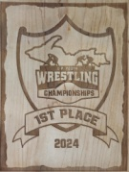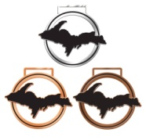
-There will be a free WARZONE available to wrestlers looking for more matches
-Wrestlers not participating in the Championships will also be eligible for WARZONE for the
price of their admission
-There will be several drawings including a high end St. Croix Fishing Rod, 50/50s and a 2023 Polaris Sportsman 450cc 4x4 Quad from RACE DRIVEN!!!
-Concessions will include Domino’s Pizza!!!
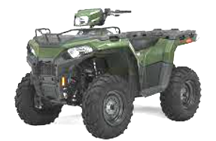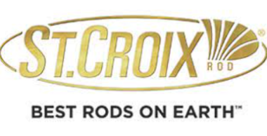
Register at: https://wrestlingtournaments.com/events/395
More Details to follow!!!
Find us on facebook: “U.P. Power Wrestling” (please answer questions)
also, visit our website: www.uppowerwrestling.org
